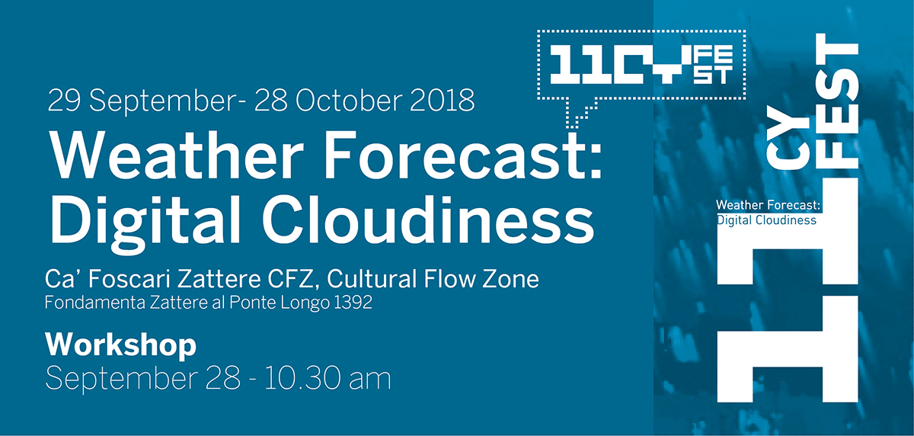

The International media art festival CYFEST-11 presents:

WORKSHOP WEATHER FORECAST: DIGITAL CLOUDINESS

Venice, Italy
September 28 2018 10.30 am

Ca' Foscari University of Venice has dedicated attention and research to the field of relationships between new technologies (digital and multimedia), artistic and cultural heritage and contemporary artistic practice. This has been carried out through exhibitions (from the beginning of 2009), international conferences (in particular the cycle on "New Perspectives New Technologies", 2011 and 2013), meetings and round tables, in which survey perspectives, specific devices and elaborate research projects were presented. A dialogue that has involved dozens of universities and research centers from every continent and in which artists, scholars and curators confronted. The fruitful relationship with "CYLAND" MediaArtLab started in 2011, coinciding with the 54th Biennial of Visual Arts.

On September 28th at 10.30 am, during the preview, of the exhibition WEATHER FORECAST: DIGITAL CLOUDINESS curators and artists organized a workshop open to everyone to discuss science applied to art and new technologies.

Keynote speakers:
ALEXANDRA DEMENTIEVA (Belgium)
Convergence as a new method
Human history gives many examples of how people are trying to understand and describe the world around us. Art and science play an important role in this process. The topics and methods have different traditions, and the target audiences are different, but the motivations and goals are basically the same. Several decades these two anthropological practices were separated and made their own ways till the 20th centaury.
Since 60th artists began to use different innovative technical tools invented by applied science that enlarged their palette of activities but it brought to a crucial division on traditional arts and multimedia. And it was lasting nearly 50 years.
Nowadays there is an important shift to converge these two art practices and we see more and more works that use the both approaches in their creations: traditional sculpture materials as wood or clay, oil painting and drawing in combination with software and hardware.

VLAD STRUKOV (UK)
Organs on Display: Technologizing the Body in Contemporary Art
(Human) body as a medium is used in a number of arts such as dance, performance and others. Technology is often imagined as something that exists in opposition to the human body, or even threatens it. Theories and projects exploring how the human body can be extended with the help of technologies are abundant. In this presentation, I consider how organs—the heart, lungs, and so on—can be used as a medium in contemporary art. More specifically, I look at how organs are technologized. For example, I discuss how organs are thought of as technologies of vision. I critically survey projects that use organs as elements of installations and display to portray technologies.

Discussants: Marina Alekseeva, Giuseppe Barbieri, Silvia Burini, Alexandra Dementieva, Anna Frants, Ivan Govorkov, Aleksey Grachev, Elena Gubanova, Sergey Komarov, Marco Nereo Rotelli.

